ISSACK WAITHAKA
cs-sa07-24085

Tier 1

Appointment
- The first step was to connect to the openvpn and then spawn the machine
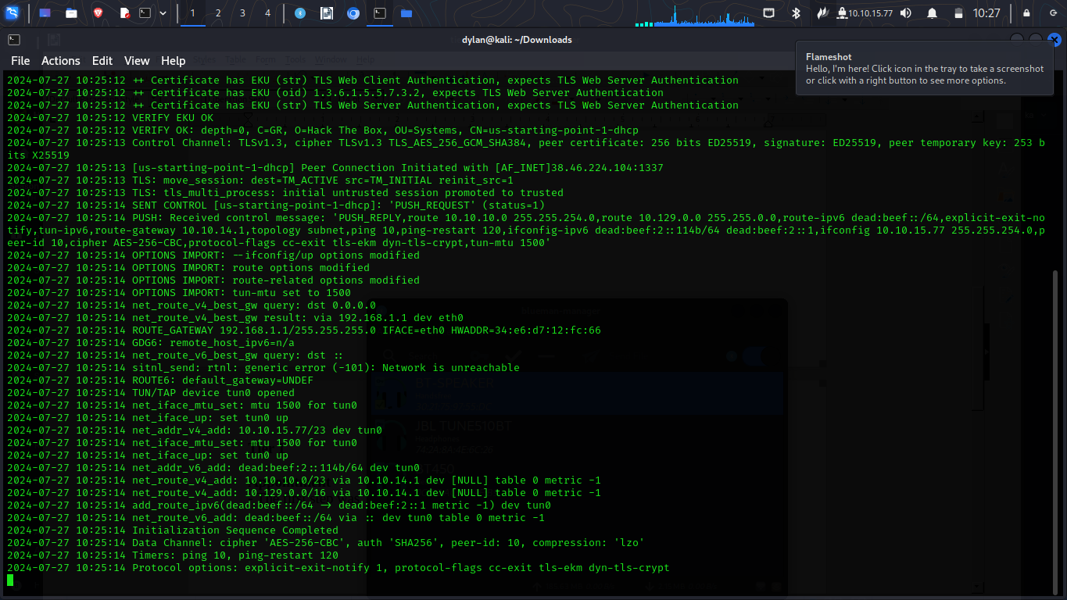
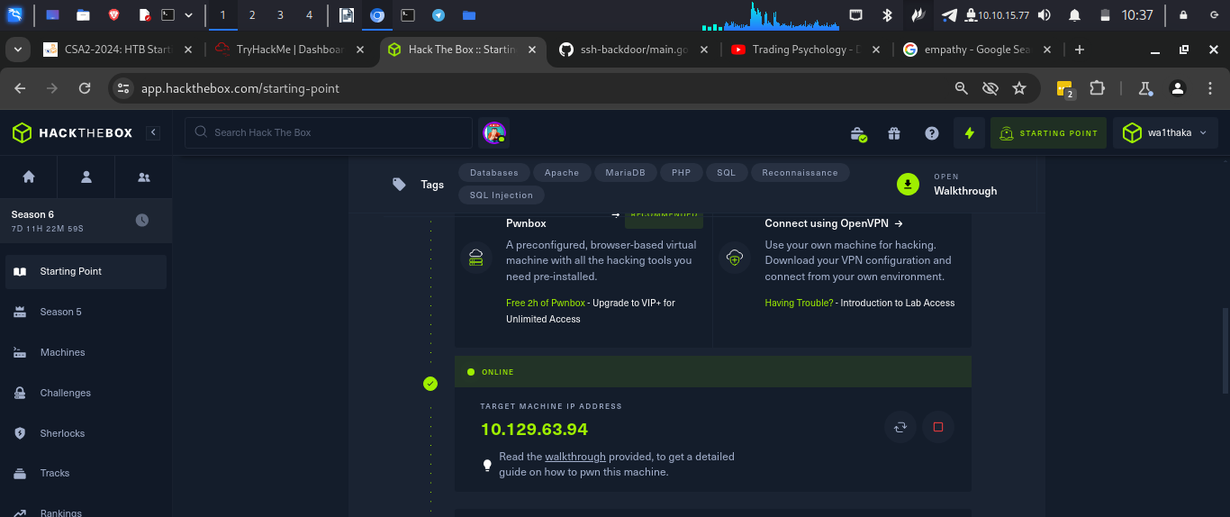

Questions
1.

2.

3.
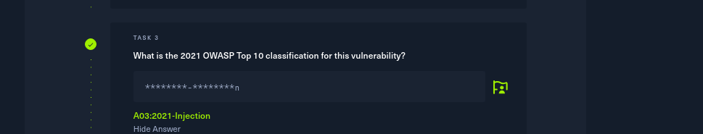
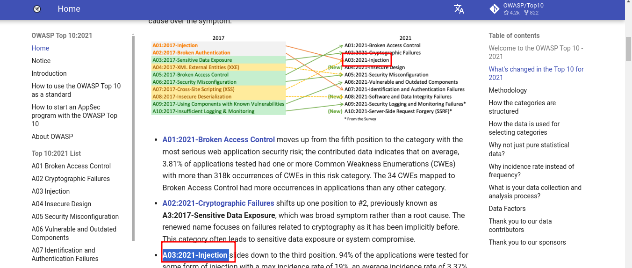

4.
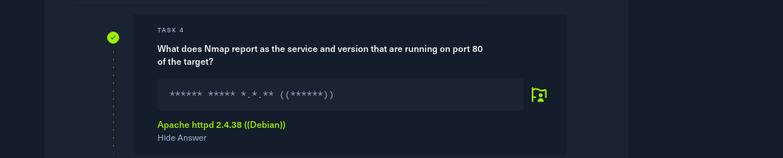
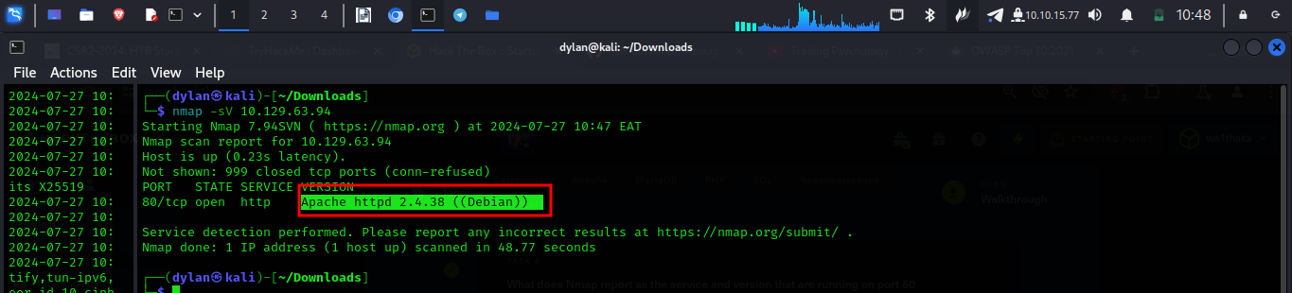

5.


6.
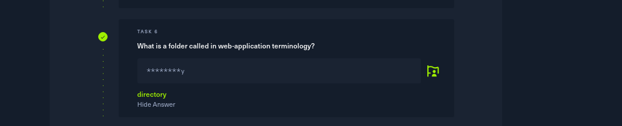


7.
8.
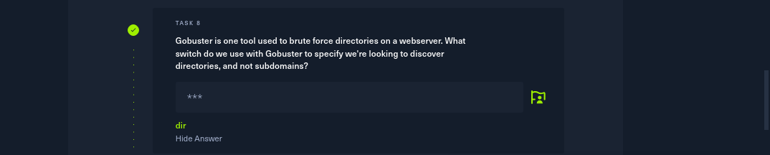
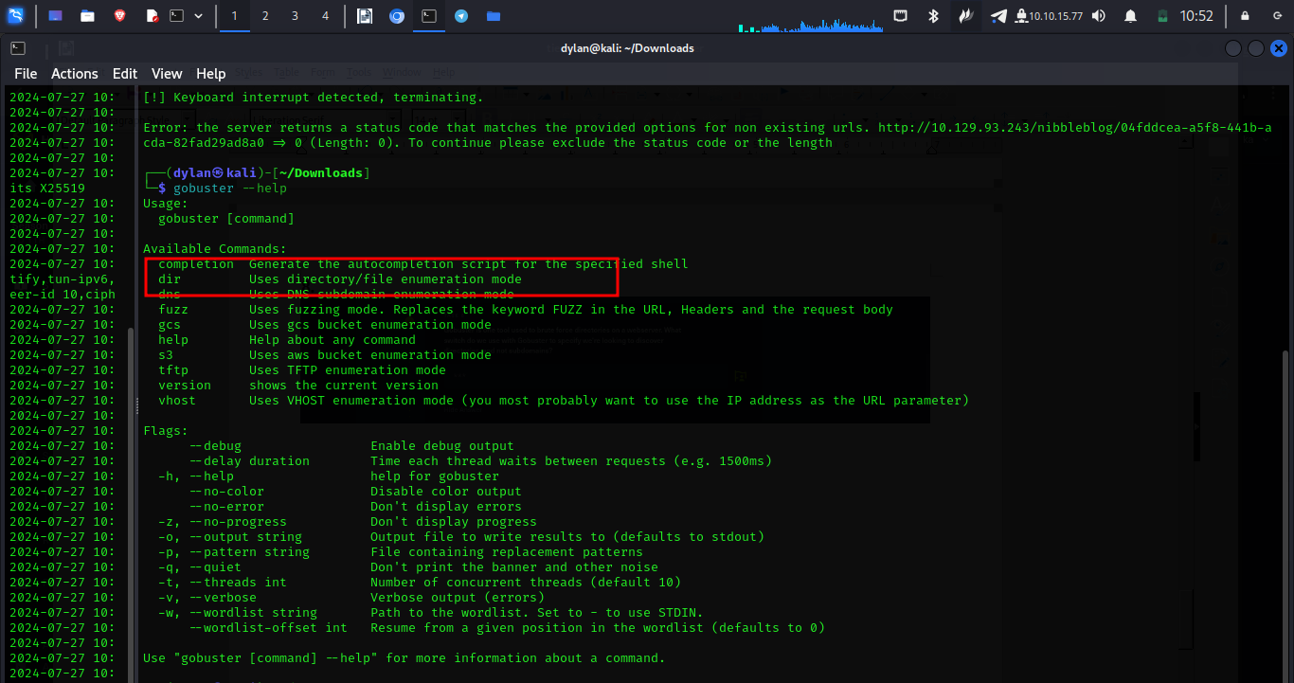

9.



10
- For this I used the comment I learnt from the previous task. I used admin ‘ #

11.
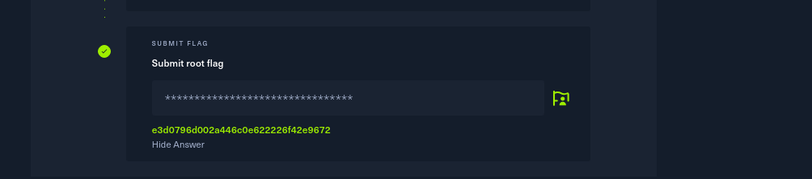
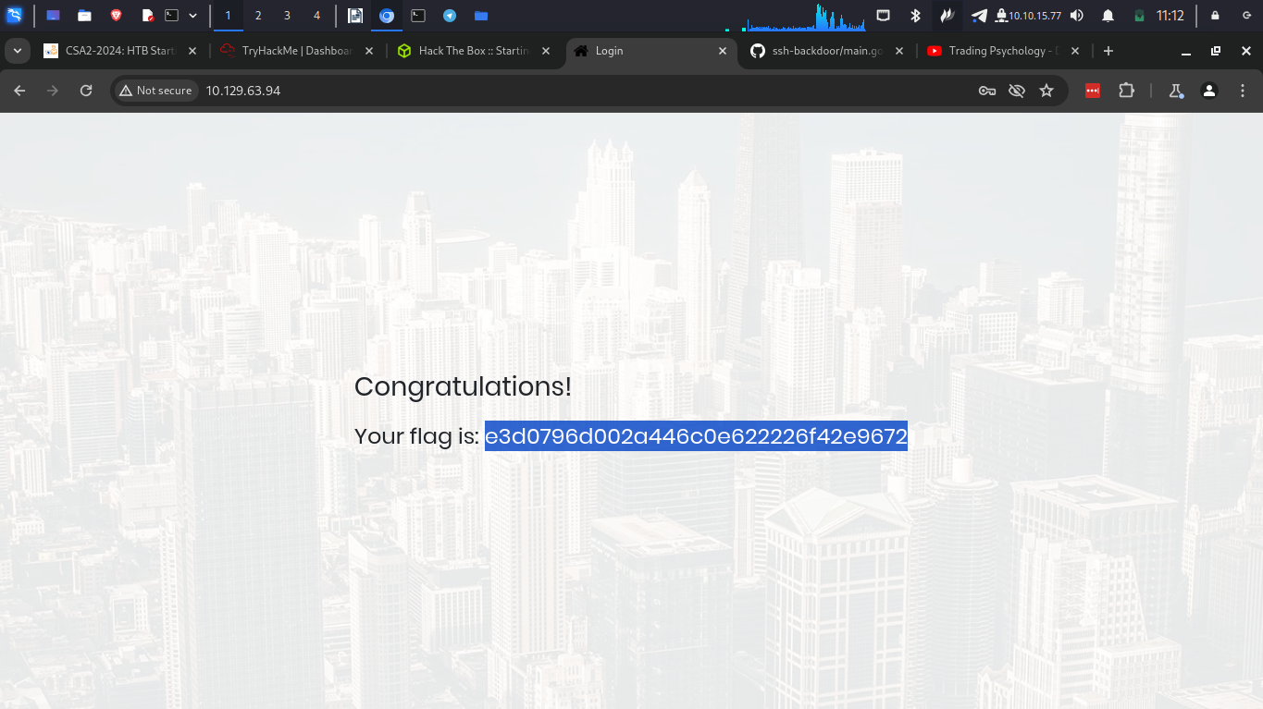

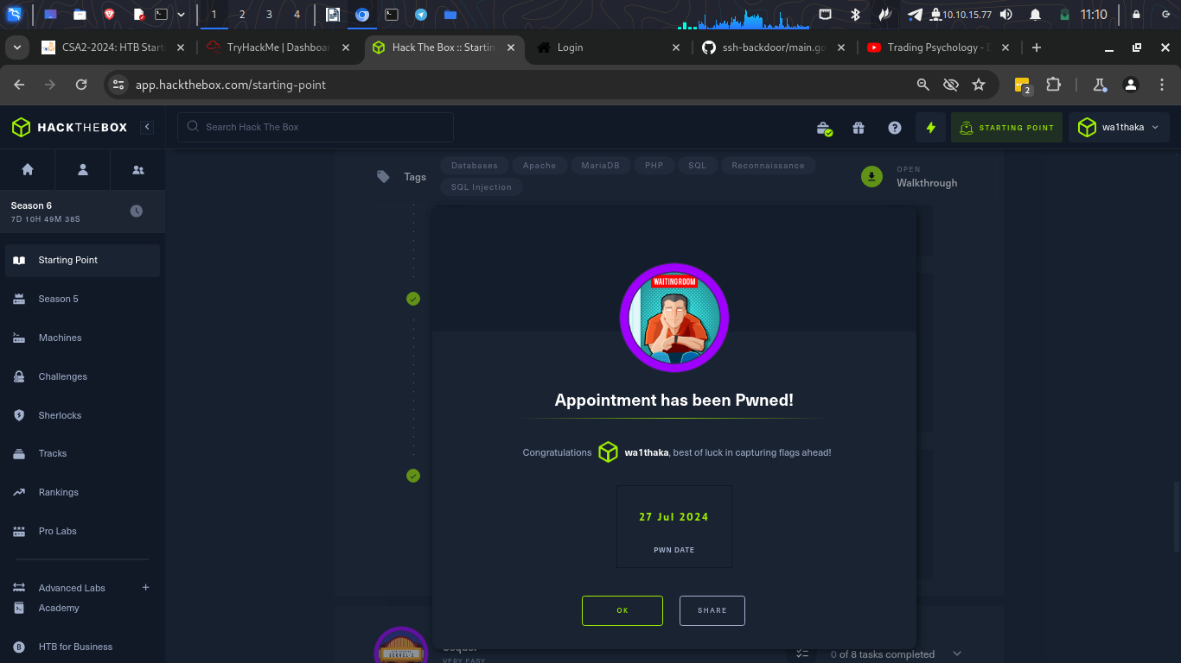
Conclusion
-In this module I have learn about sql and how to exploit sql vulnerabilities

Sequel
The first thing was to connect through openvpn and spawn the target machine.

Questions
1.

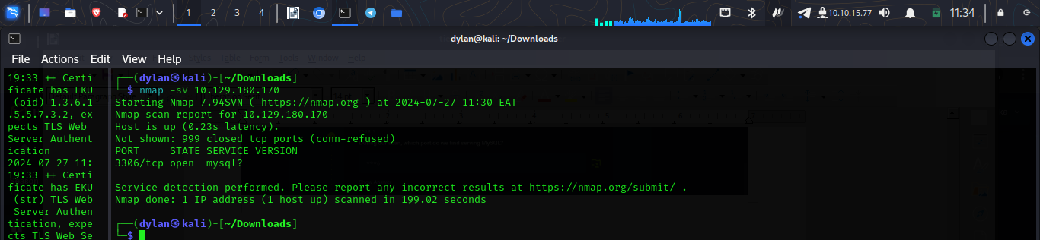

2.

In question I had to add ‘sC’ to my nmap command to run safe script which is good way to get things like versions

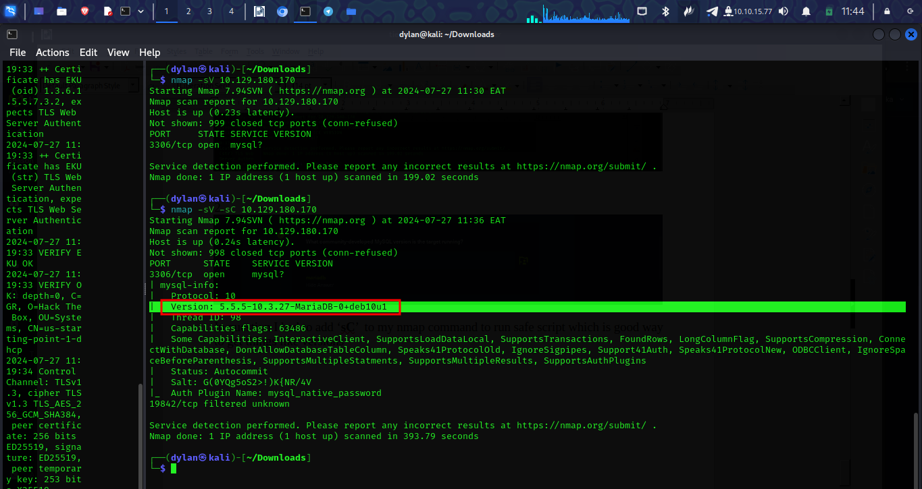

3.
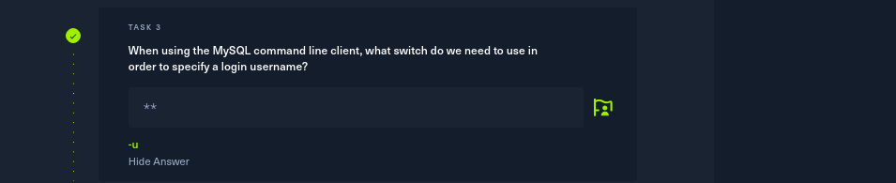
4.

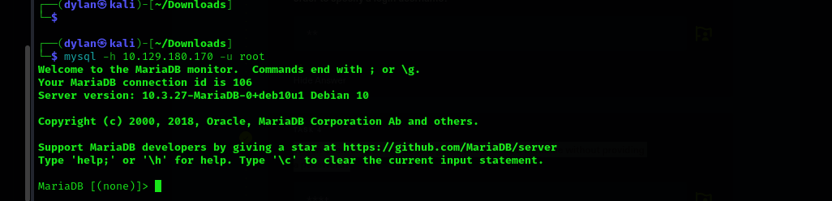

5.


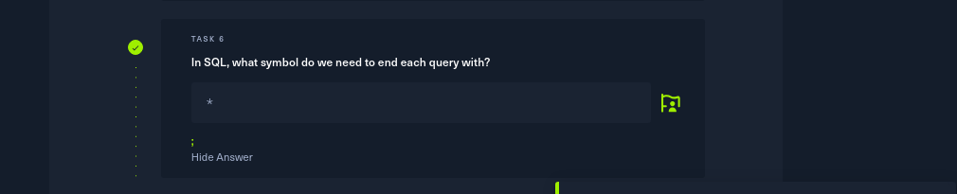
6.

7.
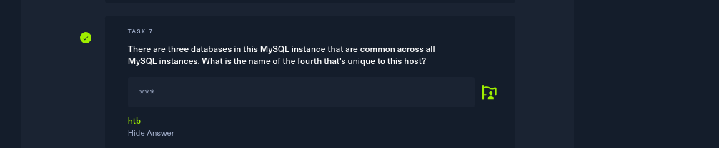
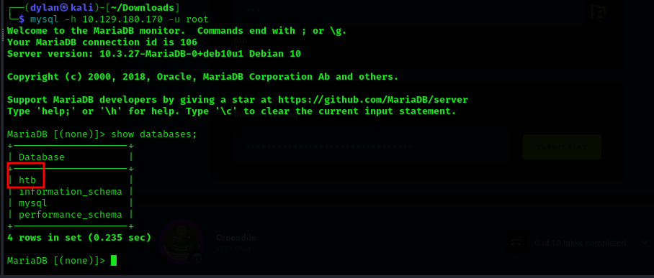

8.
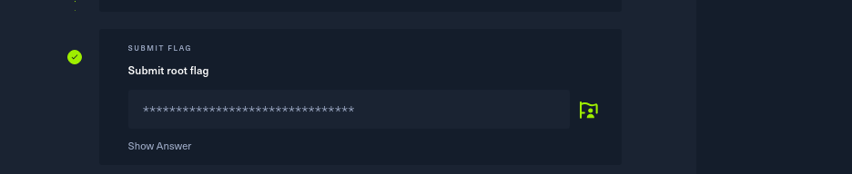
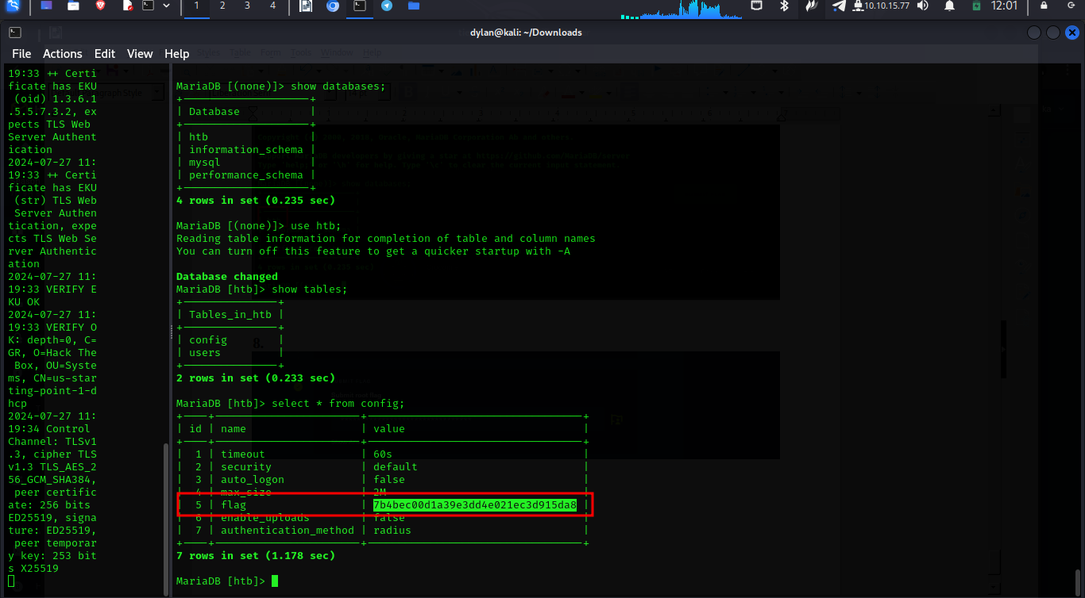

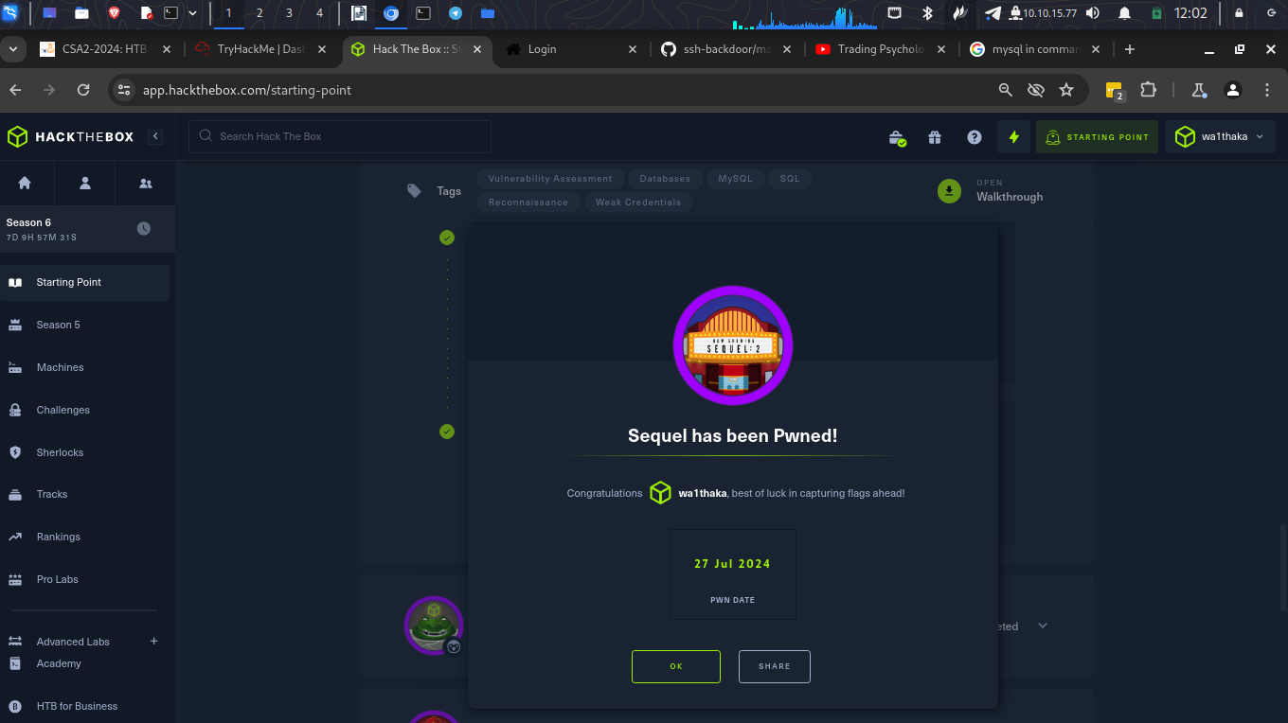

Conclusion
In this room I learnt how to access the mysql databases through the command line

Crocodile
- The first step was to spawn my target machine


Questions
1.
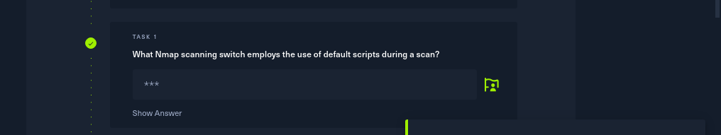
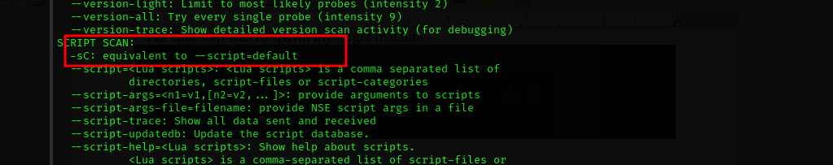

2.
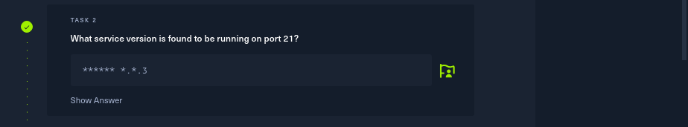
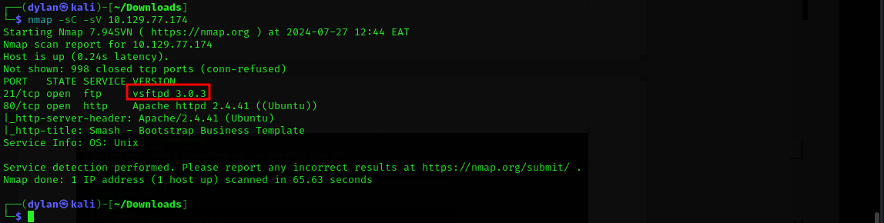
3.
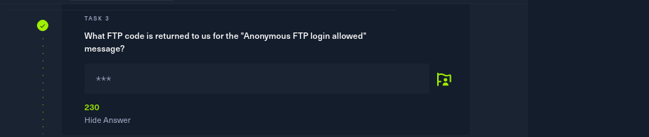

4.
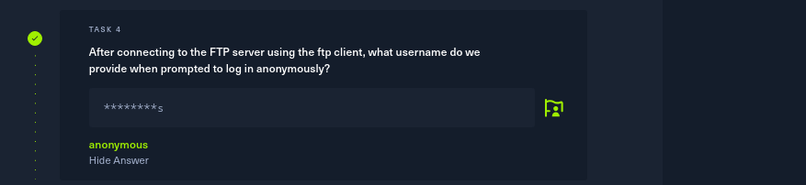
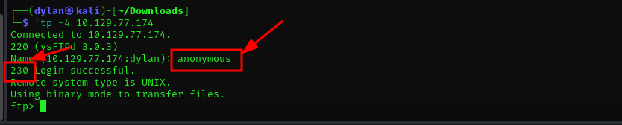
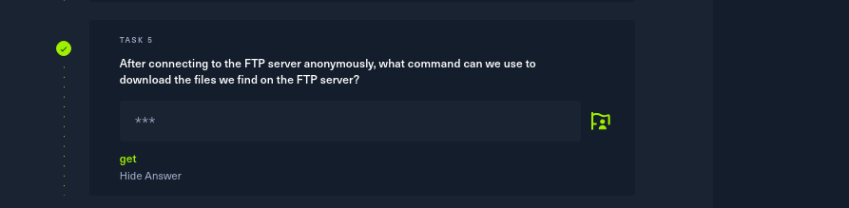
5.

6.
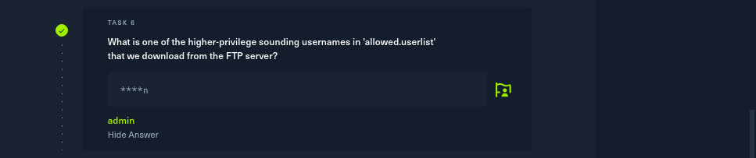
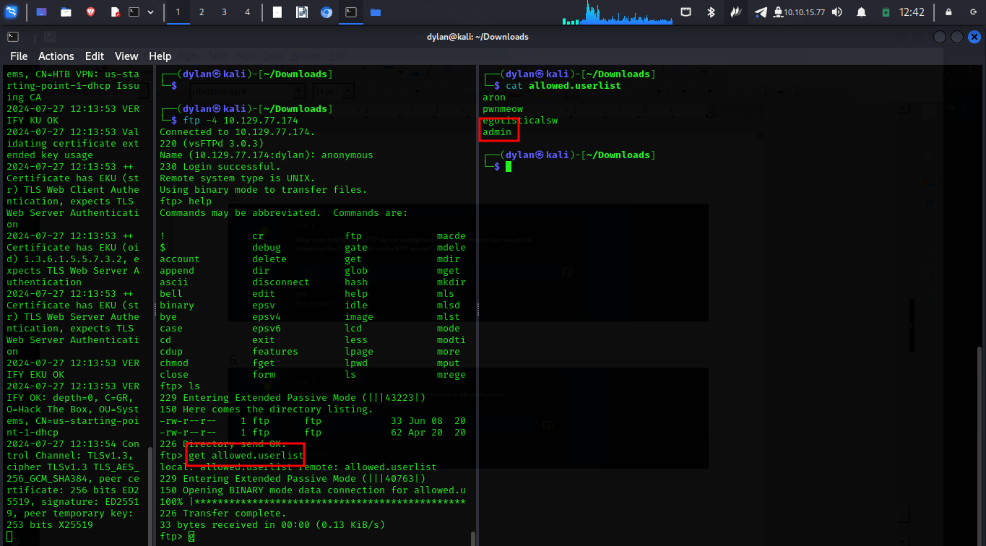

7.
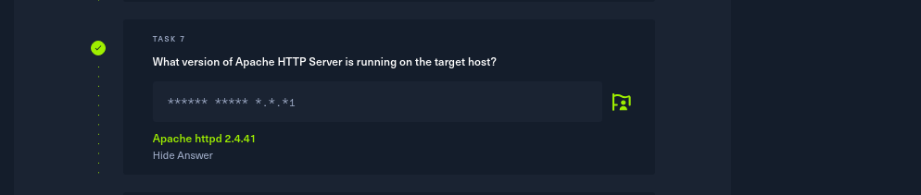
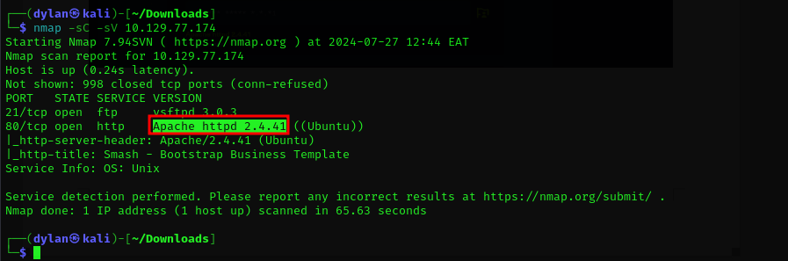

8.
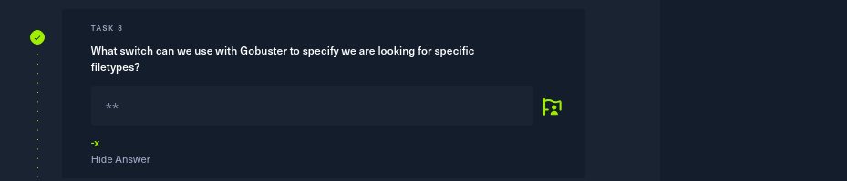
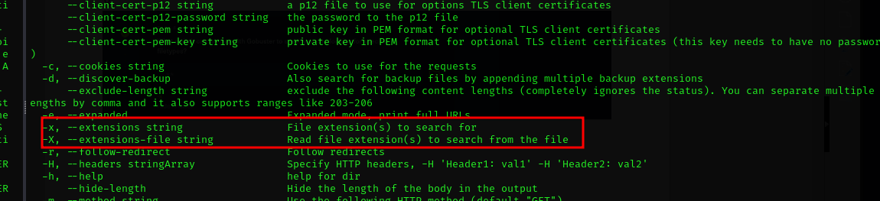
9.
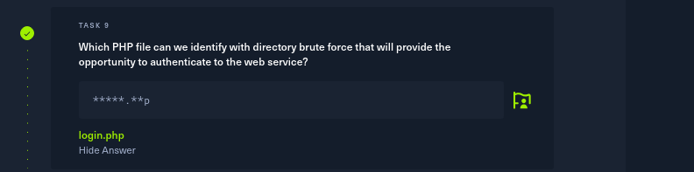
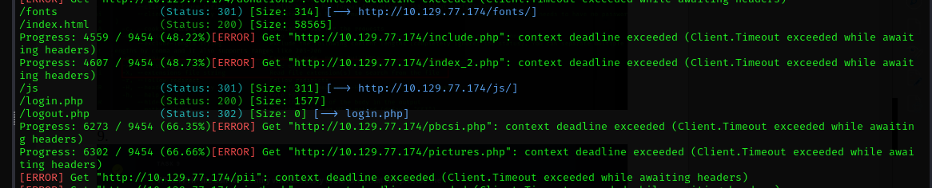

10.
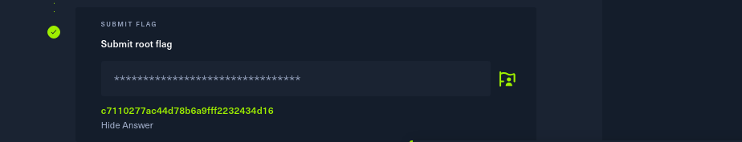
For this I had to download the file other file ‘allowed.userlist.passwd’ which contained the password.

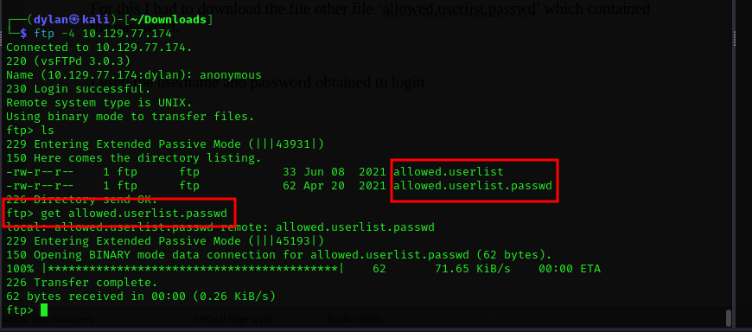
I used the username and password obtained to login
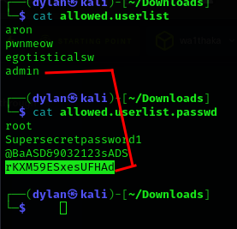

NB: I had to restart machine because it stopped before I could take a screenshot
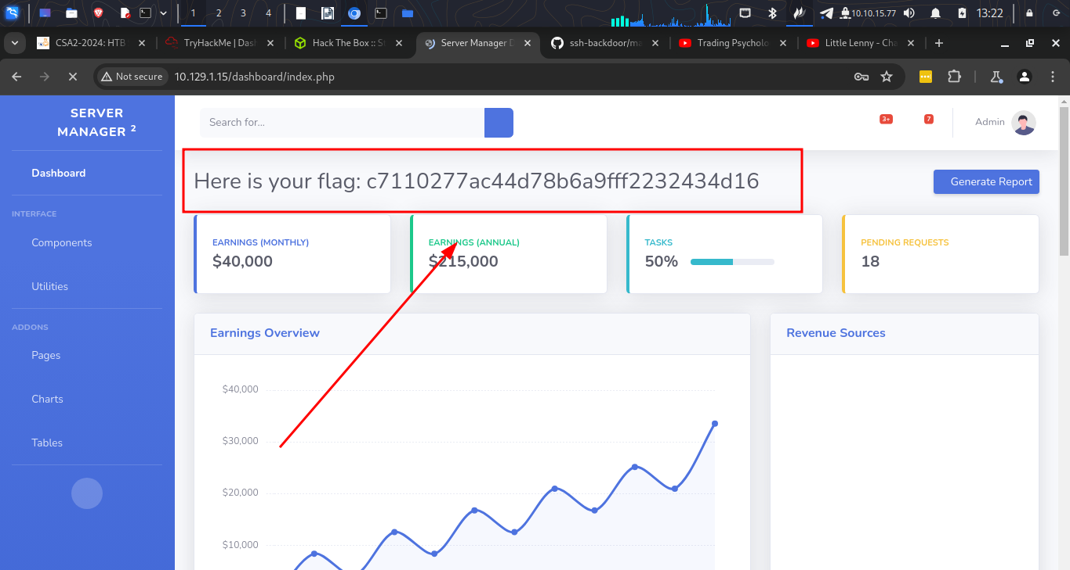

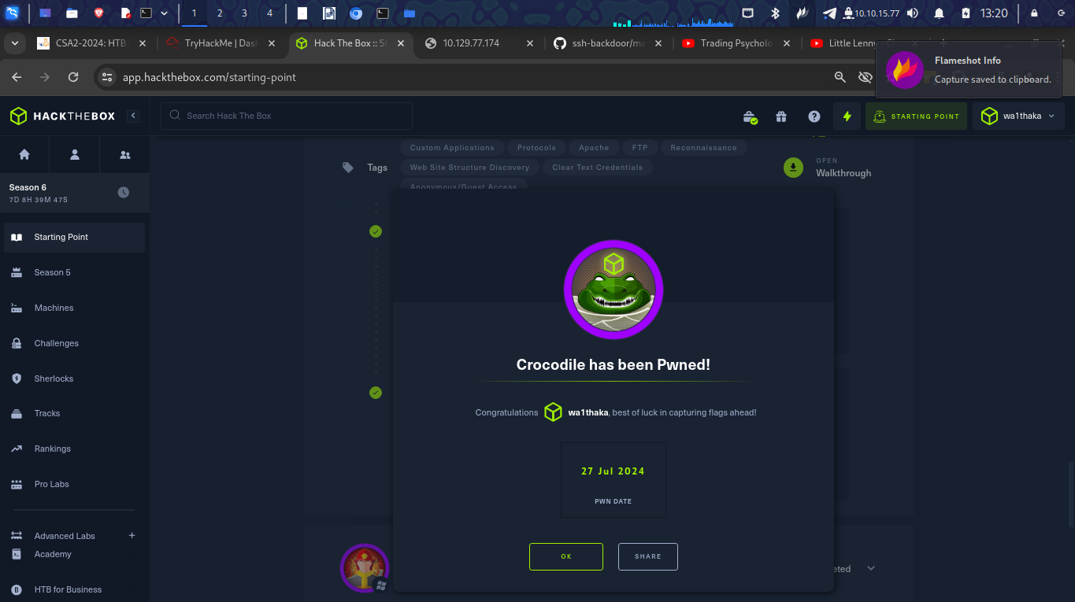

Conclusion
I was able to remind myself how to use FTP protocol

Responder
- The first thing I did was to spawn my machine
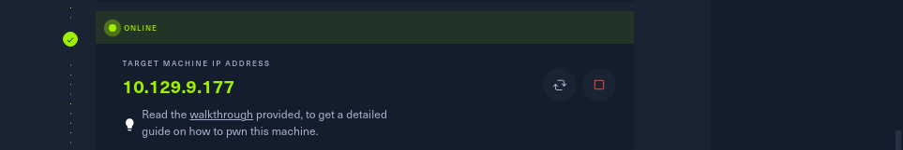
Questions
1.
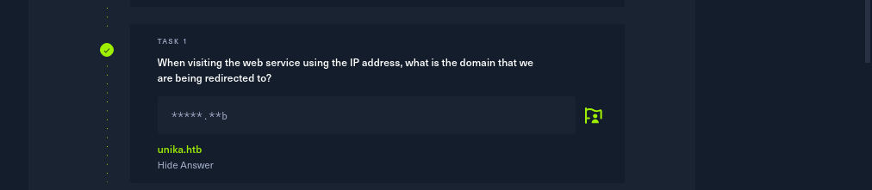
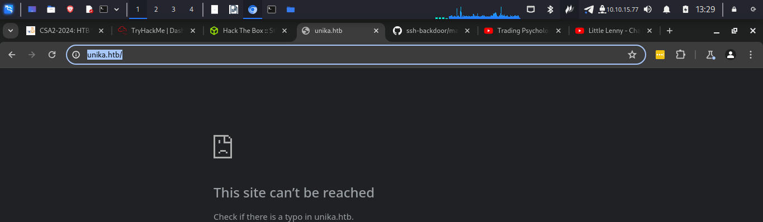
In order to view this web page I needed to add its IP address to the /etc/host file.

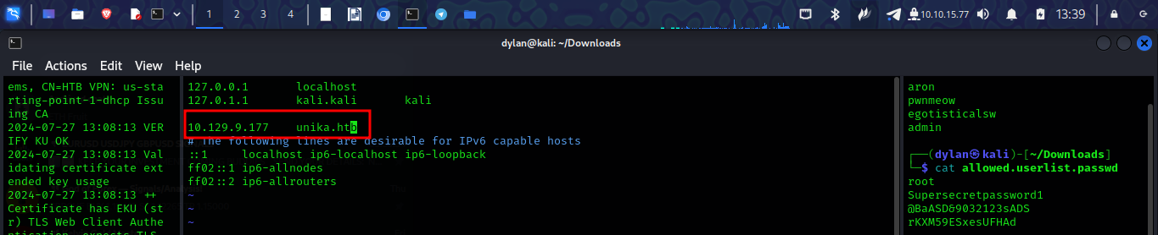
and it worked


2.
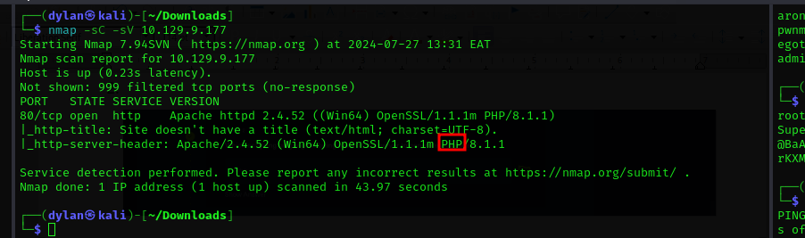

3.
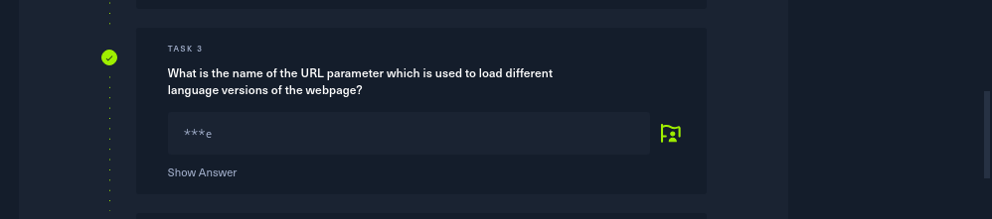
for thin I had to change language to french to see what changes would appear in the url
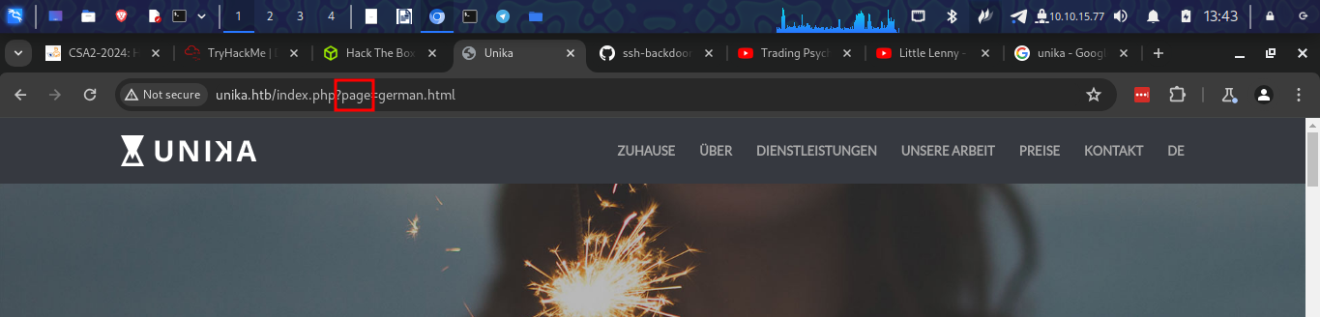
4.
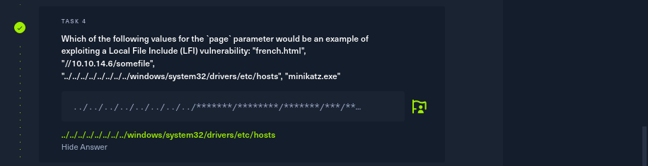

5.
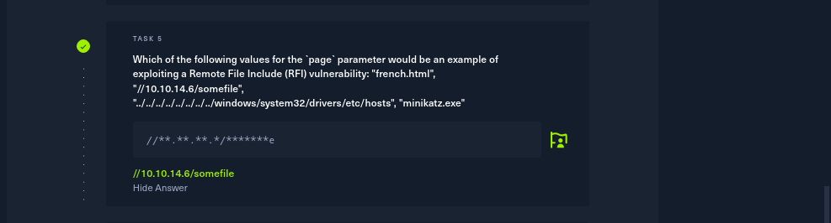

6.
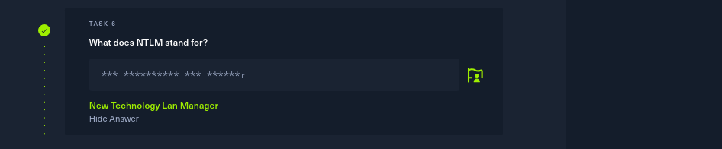
7.
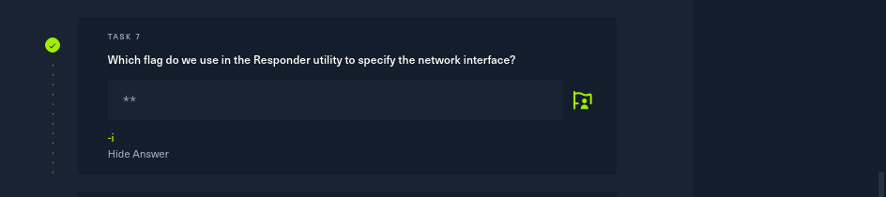
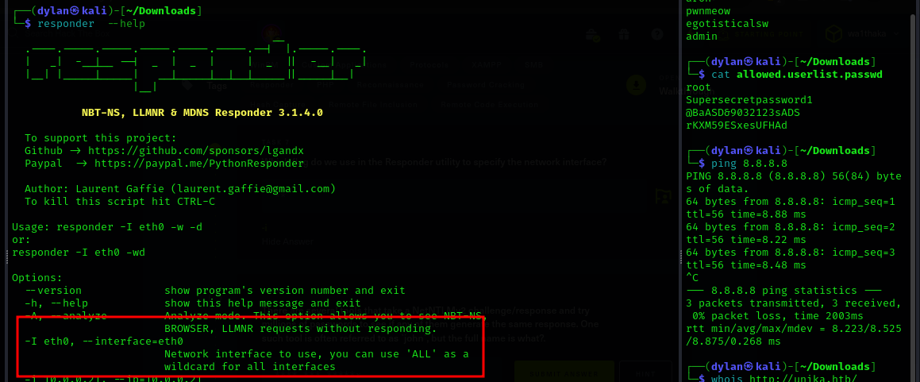

8.
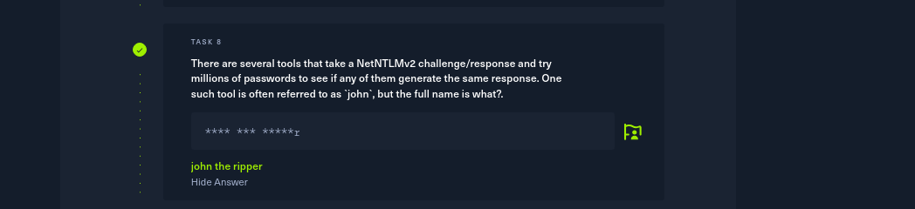
9.
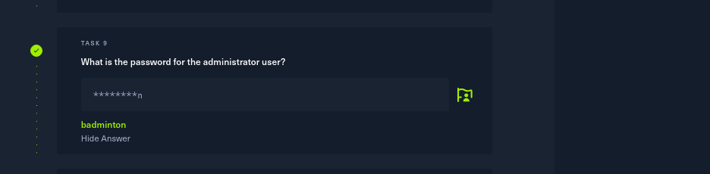

I used responder to specify to the target.
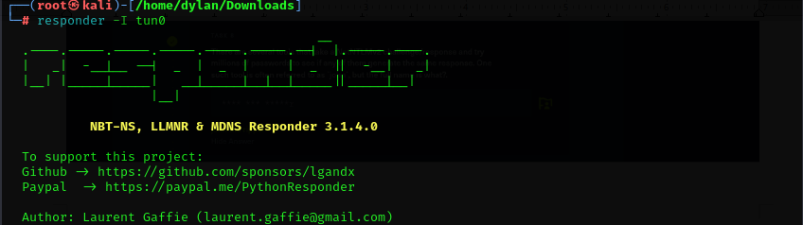
To capture events I tried to open file using the IP and a shared folder name

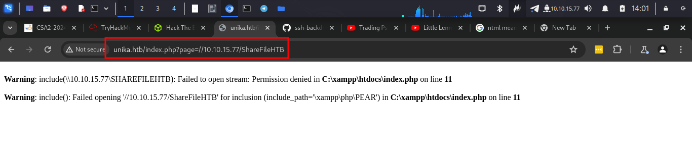
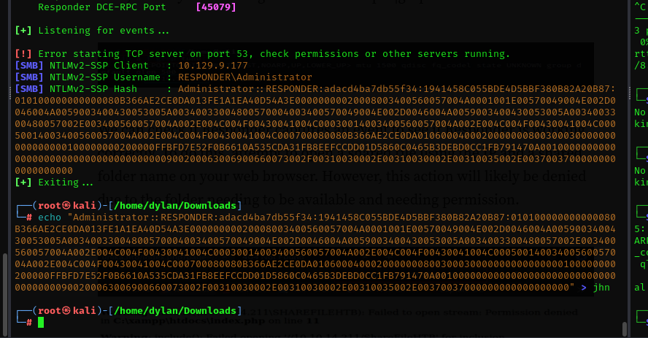
I got response which I placed in a file

I used john to crack the hash and got the following results
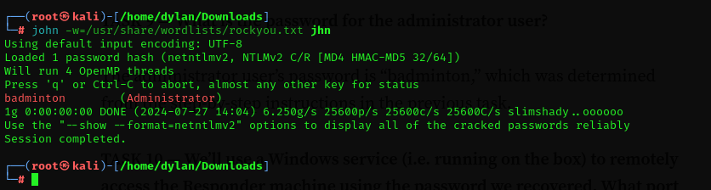

10.
I had to run a more verbose nmap for this

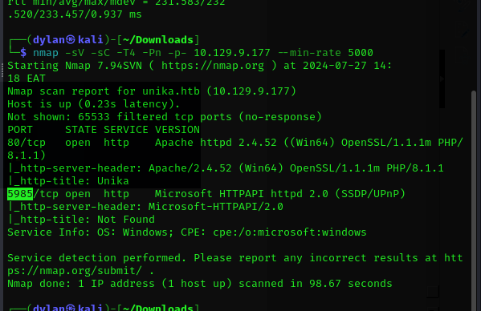

11.
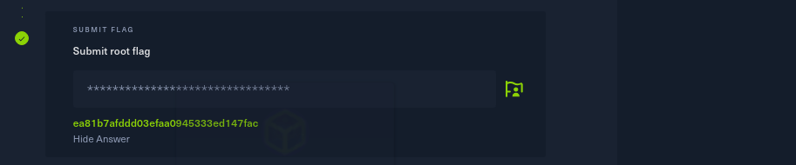
For this I used evil-wirm tool because it has a windows remote management package
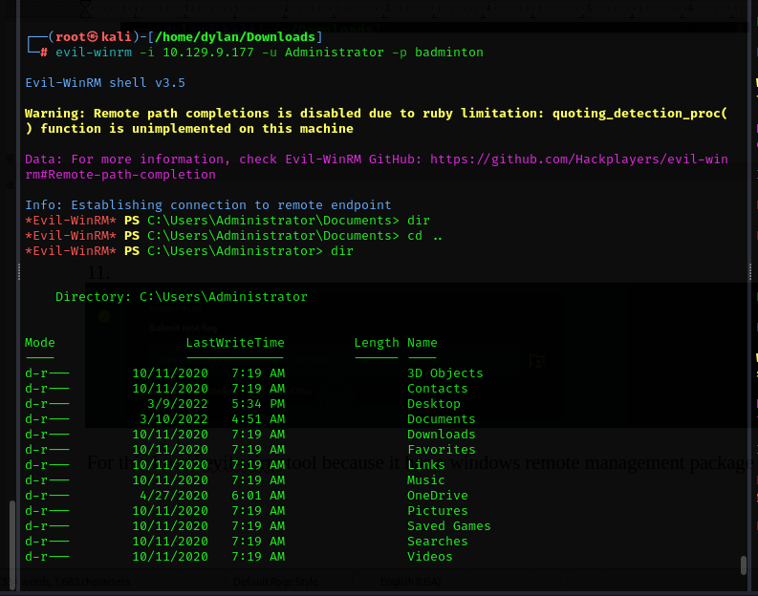
I navigated to Mikes directory where the flag was
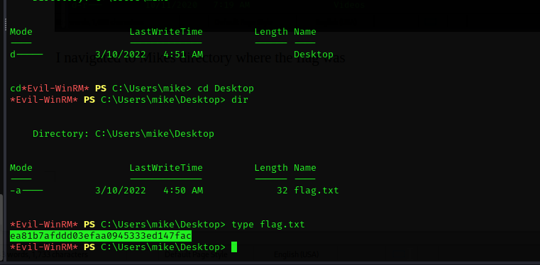

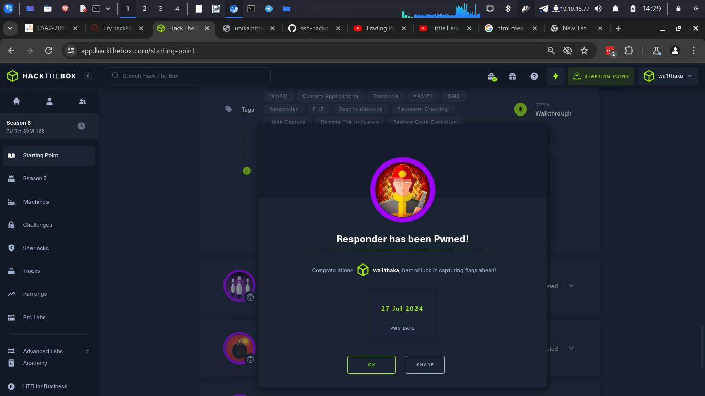
Conclusion
- In this section I learnt how to use john the ripper to crack a hash value. I also learnt how gather more information by just manipulating the url.

Very Easy
- The first thing was to spawn machine
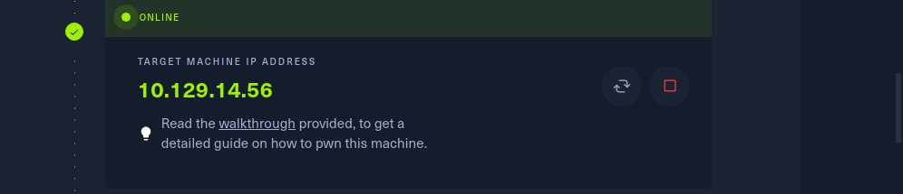

Questions
1.
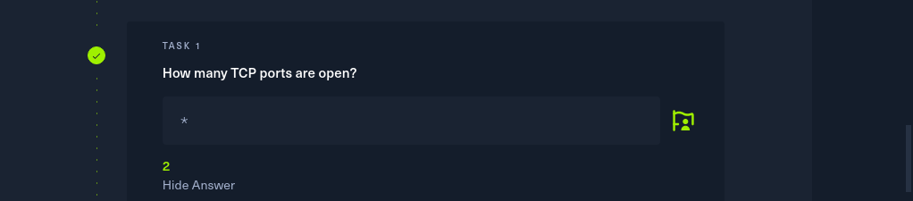
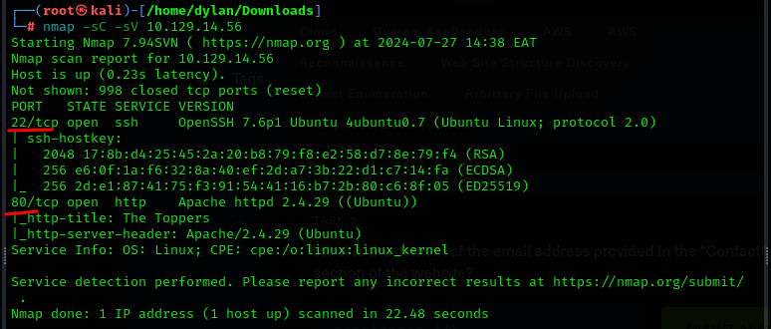

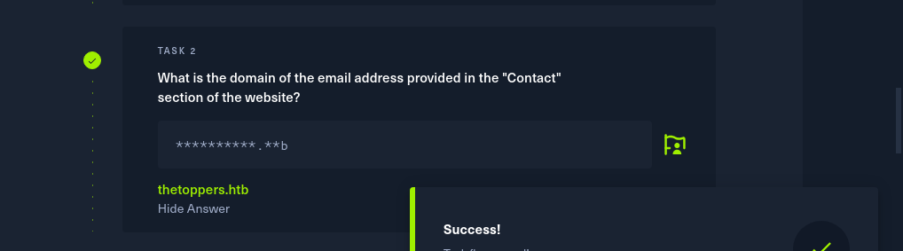
2.
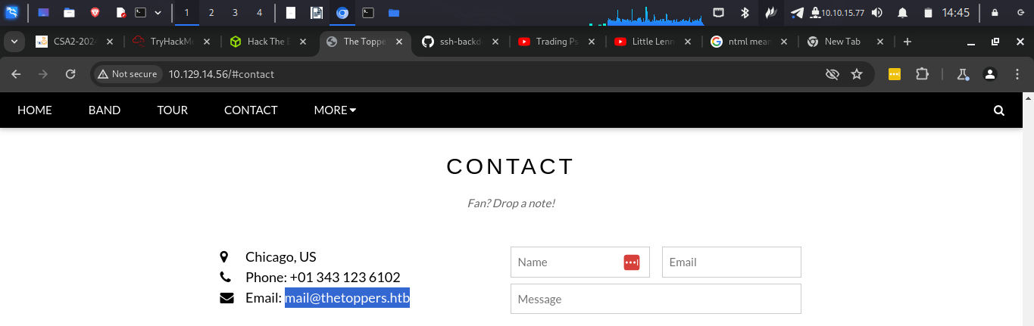

3.
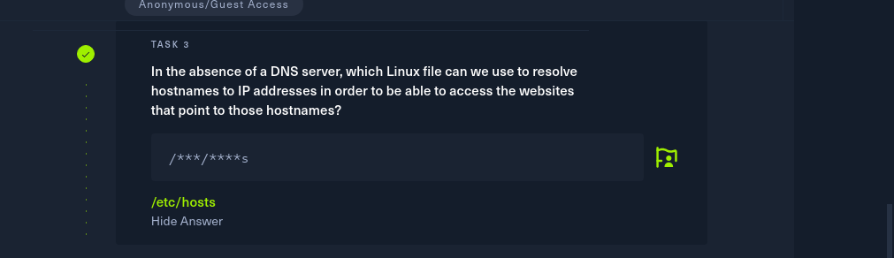
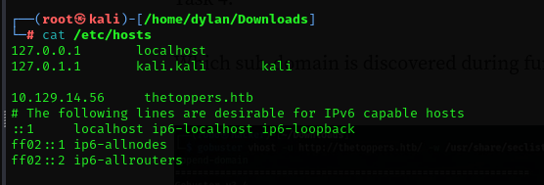
I added thetoppers hostname and Ip

4.
There are many tools for dns enumeration. Tools like wfuzz, virustotal, dnsdumpster etc.
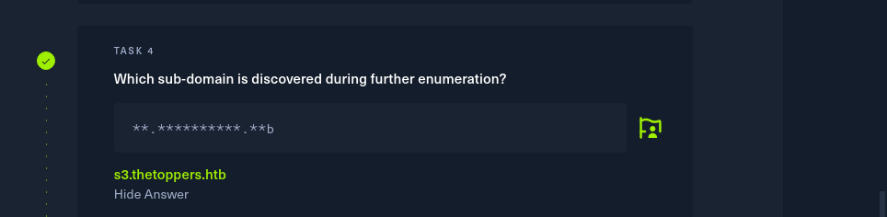
I decided to go with gobuster
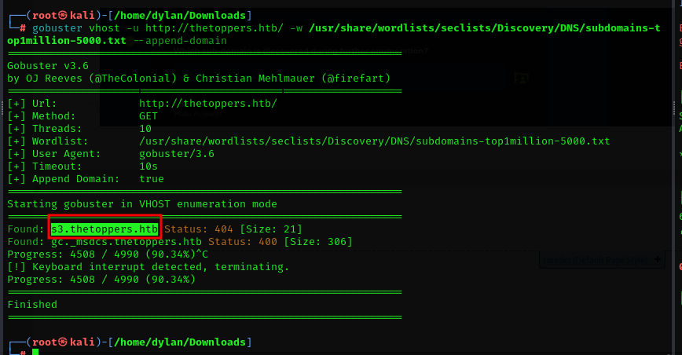

5.
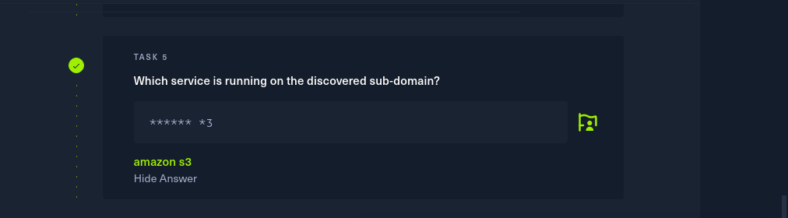
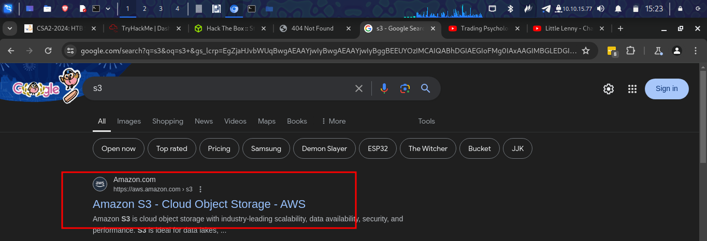

6.
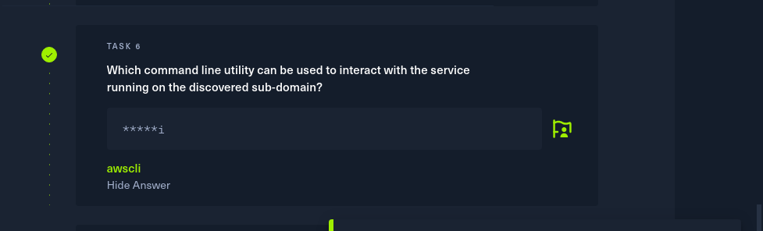
7.
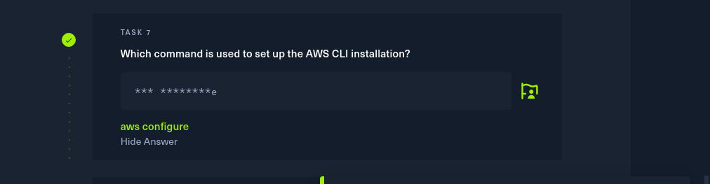

8.
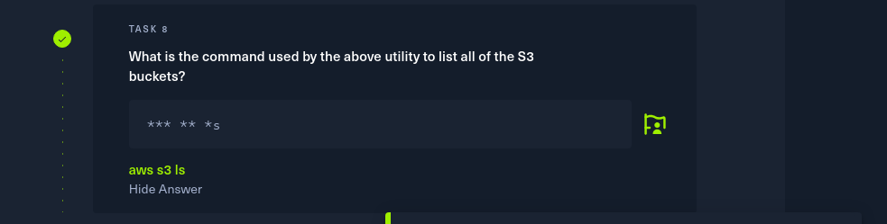
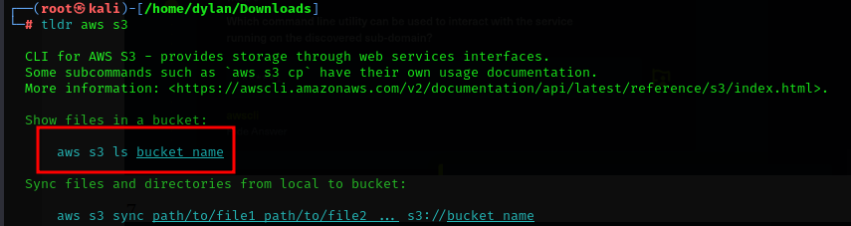
9.

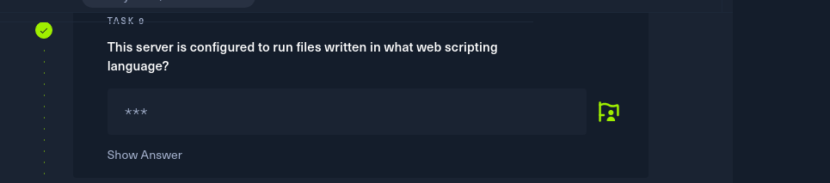

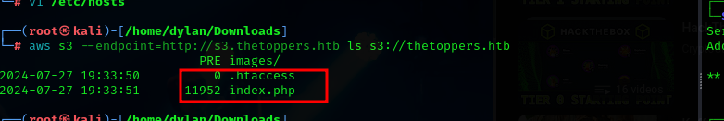

10.
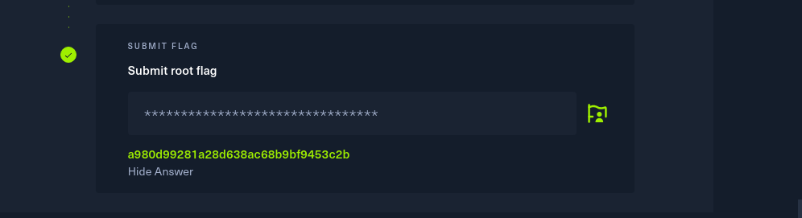

- to get the flag I had to create a php reverse shell.
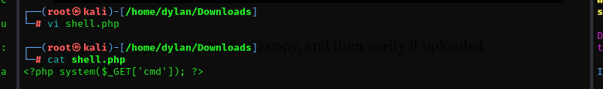

- I copied this file to the s3 copy and uploaded it
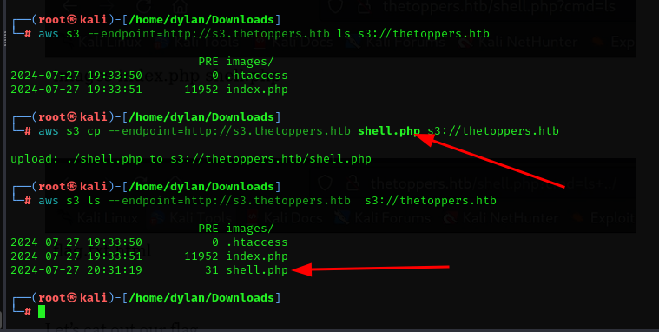
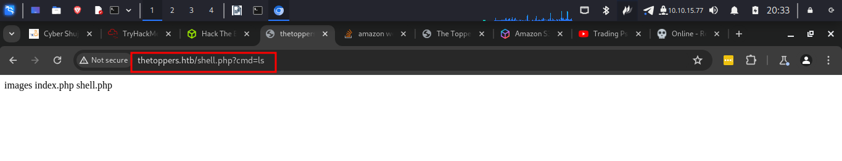
I was able to get the flag


